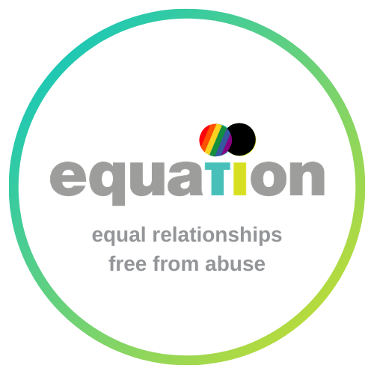

Vision
Our goal is for everyone to have equal, healthy relationships, in a society free from domestic abuse, sexual violence and gender inequality.

Mission
Equation is a specialist charity that works with the whole community to reduce the impact of domestic abuse, sexual violence and gender inequality. We:
- work to prevent domestic abuse and sexual violence by raising awareness and educating people about equal and healthy relationships.
- Ensure survivors get the most effective support to create space for action: we facilitate a co-ordinated approach across the sector and provide practical tools and guidance to support survivors.

Values
There are 5 core values that drive all Equation’s work.

- Positivity – Equation looks forwards to creating a world without domestic abuse, sexual violence and gender inequality. Our outlook is aspirational and we seek to drive forward change
- Passion – We challenge the status quo with tenacity and an energetic commitment to ending domestic abuse, sexual violence and gender inequality
- Rigor - our work is based on solid evidence and a considered approach
- Compassion – we prioritise the wellbeing and safety of survivors, their children, and the whole community
- Collaboration – we work in partnership against domestic abuse

Explanation of terms
everyone means people of all genders and life stages
equal in this context means that both people in the relationship give each other the same value and respect, regardless of any differences in their age, gender, sexual orientation, ethnicity, income, ability, status or life experience.
healthy in this context means mutually demonstrating key healthy relationship values: trust, respect, kindness, compromise, understanding, love, intimacy, honesty, safety, affection, and support
gender inequality means when people, particularly women, are unfairly disadvantaged because of their gender identity
Domestic abuse is when someone uses behaviour that is intended to control, coerce, threaten or harm a person who has, or has had, an intimate or family relationship with them.
Domestic abuse can involve violence and physical harm, but not always. It can also involve emotional bullying and psychological abuse, sexual violence or financial abuse, harassment, and stalking. Coercive or controlling behaviour (or ‘coercive control’) is abusive behaviour designed to gain power and dominance over another person and involves intimidation, degradation, isolation, and deprivation of independence.
Domestic abuse is rarely a one-off incident, and usually involves a pattern of abusive behaviour.
A person using abusive behaviour can act alone, or involve others in committing the abuse.
Forced marriage, so-called ‘honour’-based violence and female genital mutilation (FGM) are forms of domestic abuse.
Sexual violence is any unwanted sexual act or activity, which means any sexual act or activity that a person has not consented to. A person consents if they agree by choice, and has the freedom and capacity to make that choice. Sexual violence includes, but is not restricted to, rape or sexual assault.
Rape is sex without consent. Rape is legally defined as the penetration with a penis of the vagina, anus or mouth of another person without their consent.
Sexual or indecent assault is an act of physical, psychological and emotional violation, in the form of a sexual act, inflicted upon someone without their consent. It can involve forcing or manipulating someone to witness or participate in any sexual acts, including being forced to watch pornography or being forced to send sexual images.
a society free from gender inequality would be a society in which women and girls are not disadvantaged because of their gender, and in which everyone has equal rights, responsibilities and opportunities regardless of their gender

© Equation February 2017

