Your Choice Project Referral form | 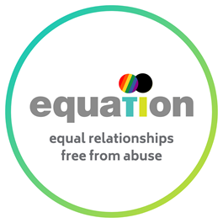 | 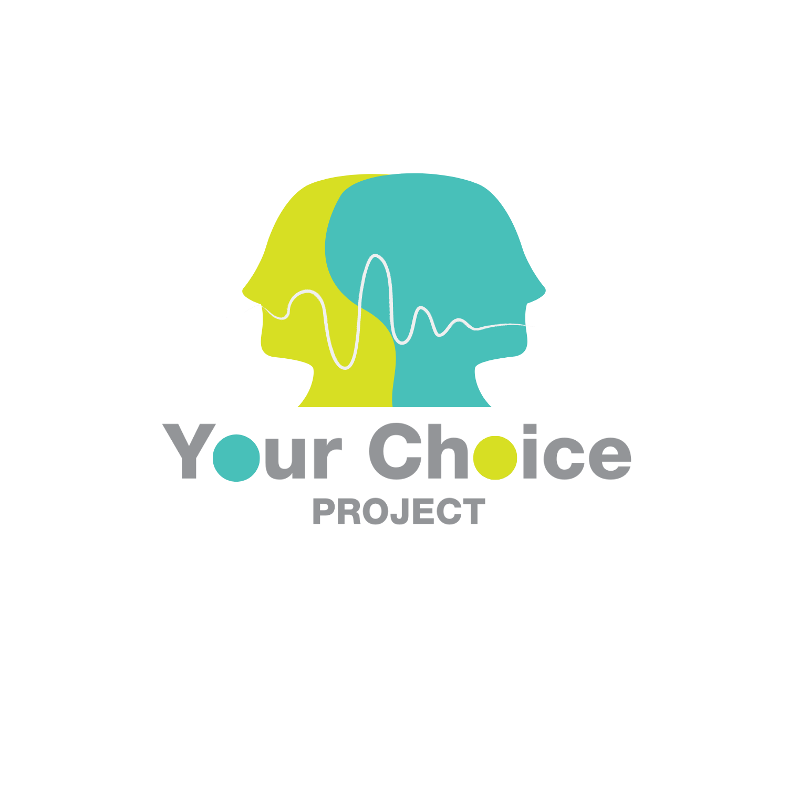

Please fully complete this referral form.
Failure to do so will result in a delay in the referral being processed.
Thank you.

Referrer details
Name: |  | Date of Referral:
Email address: |  | Phone number:
Please confirm that consent has been gained for this referral: | Yes No  Please note, we cannot accept referrals without the Client’s consent

Details of person being referred
Name:  (preferred pronouns) |  | D.O.B:
Email: |  | Phone:
Support required for engagement (Interpreter, language, literacy, etc): |  | Address:
Gender: |  | Sexuality:
Ethnicity: |  | Religion:
Status of any child or adult safeguarding measures:
Has there recently been or is there going to be a separation from partner? |  | Are there ongoing care proceedings? If so please give details
Details of current criminal/family court proceedings or injunctions concerning domestic violence and abuse: |  | Details of previous criminal convictions, injunctions, cautions or arrests for domestic violence and abuse:
Current relationship status:
Has a DASH RIC been completed within the last 12 months? | If so, please confirm score/risk level:
Type of abuse  (Please put an X next to the type/s of abuse used) | Physical  Sexual  Coercive control  Economic/financial  Emotional  Violent or threatening behaviour  Harassment and Stalking
Mental health concerns: | (If yes, please describe)
Substance misuse concerns: | (If yes, please describe)
Has Client engaged in any Domestic Abuse work previously? | (If yes, please describe and provide dates)
Is Client currently engaging in any other behaviour change work or treatment such as counselling, substance misuse treatment, psychiatric treatment, etc? | (If yes, please describe)
Are there any risks to professionals posed by the Client that you are aware of? | (If yes please describe)

Children’s details
(all children connected to perpetrator - including stepchildren, foster children, and any other children in the home or under their care)

First name | Surname | Date of birth |  | Sex | Living and contact arrangements
Is there, or has there been, disagreement about child contact arrangements:

Yes No

Is there an intention to issue Children Act proceedings or are there Children Act proceedings before the Family Court currently?

Yes No

Please confirm status of any court proceedings:

What are the current child contact arrangements?

Is Children’s Social Care involved with the family? |  |  | Yes No
Name of Social Worker
Contact details of social worker
Details of involvement

Other agencies
Is Adult Social Care involved with anyone in the family? | Yes No
Name of Social Worker
Contact details of social worker
Details of involvement
Are any other agencies involved with this referral? | Yes No

Agency 1
Name of worker
Contact details
Detail of involvement
Agency 2
Name of worker
Contact details
Detail of involvement

Referral details
What has led to this referral? Please provide details of the following:
- All known incidents of DVA
- Details of risk factors
- Current DVA
- Historical DVA
- Family dynamics
- Motivation to change and address behaviour
- Any safety plans currently in place for client, partners, ex partners, family members or children
- Partner’s, ex-partner’s, family member’s preference of support (eg- emotional support, check in, updates)
- Any other relevant history
- Concerns about health and well-being of Client and/or survivors
- Protective factors

Please give as much information as possible

If you have confidential contact details for a partner, ex-partner or family member connected to the Client you are referring to the Your Choice Project, please complete this section of the form separately and ensure the details are not shared with the Client.
Please provide details with all partners/ex partners that the Client has children with.

Survivor connected to person being referred.
The YCP requires details of any partners, ex partners or family members that have experienced domestic violence and abuse with the person being referred, as known:
Name: |  | D.O.B:
Relationship to Client referred to YCP:
Email: |  | Phone:
Gender: |  | Sexuality:
Ethnicity: |  | Religion:
Address: |  | Support required for engagement  (Interpreter, language, literacy, etc.)
Mental health concerns: | (If yes, please describe)
Substance misuse concerns: | (If yes, please describe)
Are there any risks to professionals posed by survivor that you are aware of | (If yes please describe)
Is this person aware of the referral?

Yes No

Is it safe to make contact with this survivor? Yes No

Preferred/safe way to contact survivor:

Any other survivor connected to person being referred.
Name: |  | D.O.B:
Relationship to Client referred to YCP:
Email: |  | Phone:
Gender: |  | Sexuality:
Ethnicity: |  | Religion:
Address: |  | Support required for engagement  (Interpreter, language, literacy, etc.)
Mental health concerns: | (If yes, please describe)
Substance misuse concerns: | (If yes, please describe)
Are there any risks to professionals posed by survivor that you are aware of | (If yes please describe)
Is this person aware of the referral?

Yes No

Is it safe to make contact with this survivor? Yes No

Preferred/safe way to contact survivor:

Any other survivor connected to person being referred.
Name: |  | D.O.B:
Relationship to Client referred to YCP:
Email: |  | Phone:
Gender: |  | Sexuality:
Ethnicity: |  | Religion:
Address: |  | Support required for engagement  (Interpreter, language, literacy, etc.)
Mental health concerns: | (If yes, please describe)
Substance misuse concerns: | (If yes, please describe)
Are there any risks to professionals posed by survivor that you are aware of | (If yes please describe)
Is this person aware of the referral?

Yes No

Is it safe to make contact with this survivor? Yes No

Preferred/safe way to contact survivor:

Please return referral form to:
Secure email: Info@yourchoiceproject.cjsm.net (do not use this email address unless you are sending from a cjsm email addres)
Unsecure email: contact@yourchoiceproject.org.uk (password protected)

We will acknowledge receipt of your referral.
If you do not hear from the YCP, please contact us on 0115 6950734

