Improving Agencies’ Engagement with Service Users Framework
Engagement and Support
A multi-agency approach to supporting adults who experience difficulties engaging with services in Nottingham City
Staff Support
Foreword

The following framework is for use by all services in Nottingham City when they are working with adults who do not engage and there are concerns of risk of harm or other safeguarding factors.

Nottingham City Domestic and Sexual Violence and Abuse Safeguarding Group developed this framework and would like to acknowledge that this framework is adapted from Slough Safeguarding Adults Board.

Membership of the Nottingham City Domestic and Sexual Violence and Abuse Safeguarding Group consists of colleagues from the following agencies:
Nottingham City Community Safety Team, Nottingham and Nottinghamshire Integrated Care Board, CityCare, Nottingham City Adult Services, Nottingham City Children’s Services, Nottingham University Hospitals Trust, Nottinghamshire Healthcare Foundation Trust, Juno Women’s Aid, Notts SVSS, and Equation.

This Guidance has been endorsed by the Nottingham City Safeguarding Adult Board.

This framework should be read in conjunction with:

- Multi-Agency Hoarding Framework:
This document sets out a framework for collaborative multi-agency working within Nottingham City and Nottinghamshire using a ‘person centred solution’ based model. The protocol offers clear guidance to staff working with people who hoard.
Multi-Agency Hoarding Framework

- Self-neglect Framework
Self Neglect Framework.download

Refer to Nottingham City Adults Safeguarding Board and Nottinghamshire Fire and Rescue websites for more information.

Contents

- How to use this Framework Pg. 3

- Introduction Pg. 3

- Aims of the Framework Pg. 4

- Definition of a complex person Pg. 4

- Guiding principles Pg. 5

- Understanding barriers to engagement Pg. 6

- When to instigate this Framework Pg. 7

- Wrap Around Multiple Disadvantage Team and Pg. 8
Severe Multiple Disadvantage

- Stages in the process to determine the risk Pg. 8
and needs of the individual

- Support and Engagement Multi-agency Meeting / Pg. 9
Multi-Disciplinary Team Meeting

- Review Meeting Pg. 10

- Ongoing Support Pg. 11

- If the individual is still not engaging Pg. 11

- Sharing Learning and Development Pg. 12

Appendix
- Multi-Agency Risk Assessment Pg. 13
- Process for Non Engagement Pg. 14
- Wrap around MDT Contact Assessment Form Pg. 15
- Professional Curiosity 7 Minute Briefing Pg. 20
- Adult Care and Support Needs Pg. 22
Nottingham City Improving Agencies’ Engagement with Service Users Framework

Version 5

- How to use this Framework

This document is a resource to integrate into existing policies and practice with regards to a person’s support. The framework provides support options for staff as well as the person the agency is trying to support.

The Framework will refer to work underway to support people with Severe and Multiple Disadvantage and access for specific service users to the Wrap Around Multiple Disadvantage Team.

The Framework should also be used in conjunction with the Professional Curiosity 7 Minute Briefing (see Appendix D). The following link provides access to an animation about professional curiosity as well as the 7 minute briefing:
https://equation.org.uk/professionals/

- Introduction

Recent Safeguarding Adult Reviews and Domestic Homicide Reviews have identified processes are required for service users and professionals when trusting relationships with services users (who have mental capacity and / or experience severe multiple disadvantages) are not developed or maintained, which in turn may impact on them accessing services.

Adults who experience multiple disadvantages and have diverse needs who do not engage with services (for whatever reason), are often known to different agencies. Their needs are generally longstanding and recurring and they may put themselves and others at risk.

This framework needs to be followed where there are concerns that there is a level of risk which professionals find unacceptable, and all other reasonable attempts to minimise this risk have failed.

Where the adult has parental responsibility for any children / or the children are living in the household, there is a statutory duty for all agencies to ensure the safety of the children and a referral to children’s social care is mandatory. If you are worried about a child at risk, please phone the Nottingham City Multi-agency Safeguarding Hub on: 0115 876 4800.

This framework can and should be used by any agency from the statutory and voluntary sector.

- Aims of the Framework:

- To improve outcomes for adults at risk who do not engage with services.

- To develop a person-centred, multi-agency / multi-disciplinary co-ordinated response.

- For agencies to work in partnership and share information to ensure best outcomes for the person.

- Understand agency barriers which stop people engaging.

- Understand a person’s circumstances which are barriers to prevent them from engaging.

- Support staff to end their involvement where everything has been done to engage and protect the person.

- Definition of a complex person / person experiencing severe multiple disadvantage (SMD)

Dr Lyndsey Harris undertook research into the pilot project Response to Complexity, which sought to provide a coordinated response to support survivors of domestic and sexual abuse with complex needs.

The research evidenced that there were multiple definitions of “complex needs” and some sectors did not like the terminology and further labelling people. It also identified that there was different understanding of the term ‘complex needs’ across the statutory and voluntary sector. This often meant that some services which would be suitable for survivors with multiple disadvantages were inaccessible due to a defined criteria of ‘eligibility’.
This led to efforts to reconsider “complex needs” in the context of protected characteristics. It is argued that when discussing victims/survivors with complex needs this should be understood as:
“Victims / survivors who experience multiple disadvantages and require a person-centred, trauma-informed approach but experience barriers and challenges in accessing essential services, which would enhance their safety, well-being and quality of life.” (Harris 2017).

- Guiding principles

- People who have the mental capacity to make decisions about their lives also have the right to make restricted choices / or ‘unwise’ / ‘unsafe’ decisions. The person may also have limited or no options/choices if they are being controlled or coerced by another person (refer to section 6 for the definition of control and coercion). Their choices may also impact upon others and/or leave them at risk of harm; this process will consider how best to balance these conflicting views.
- Information sharing by all agencies is implicit for this framework; consent should be sought to share information from the service user, unless to do so places the person or those around him/her at further risk of harm. Consideration should be given to making a Safeguarding Referral to Adult Social Care if the service user is believed to have care and support needs (see Appendix E) and / or is felt unable to protect themselves from either the risk of, or the experience of abuse or neglect. If you are worried about an adult at risk, please use the Adult Social Care Hub or call the Nottingham Health and Care Point on 01158763330.
Please refer to the Nottingham City and Nottinghamshire Adult Safeguarding Board for full safeguarding referral details:
Nottingham City and Nottinghamshire Adult Safeguarding Procedures
- Staff should seek advice from senior managers throughout the process, regarding safeguarding and legal options.
- This is a multi-agency / multi-disciplinary process and each agency is required to nominate a lead worker of sufficient seniority, to agree actions and make operational decisions.
- Consider instigating a multi-agency / multi-disciplinary meeting and if the service user is eligible, refer to the Wrap Around Multiple Disadvantage Team (see Section 8 and Appendix C).
  - One agency should be identified as the lead agency and this will be decided at the initial meeting, taking into account which agency is best suited to this role.
- If there is a service that is able to maintain a relationship with the service user then they should ensure that the individual remains “visible” to the other services by sharing relevant information with those services / agencies.
- Be professionally curious. Professional curiosity is the ability to explore and understand what is happening with a family or adult. It is about not accepting a situation as it appears, especially if it does not ‘feel’ right. It requires practitioners to act upon their safeguarding responsibilities rather than passively make assumptions or take matters at face value. A curious professional will enquire deeply by looking, listening and proactively questioning and challenging all those involved.

- Understanding barriers to engagement:

- Systems - The methods an agency uses to contact an individual.
  - E.g. person will not open letters but letters are automatically generated.
  - E.g. is provision / support time limited, “Did not attend / engagement policies” / “3 strike rule” and case closure.
  - E.g. a lack of flexibility in some key services and some services not being adequately person-centred.
  - E.g. English is not the person’s spoken language.
  - E.g. Cultural needs are not met.
  - E.g. That people can easily ‘bounce around’ the system, often with no clear joined up working between services or effective ways of sharing information to avoid the need for a service user to tell their story repeatedly.
  - E.g. That services and individuals can find it difficult to identify the right support in relation to SMD, with pathways often being complex and difficult to navigate.

- Perceived ideas about an agency and what they can provide to that individual.
  - E.g. failed interactions with this agency before.
  - E.g. “word of mouth” - negative experiences with a service.
  - E.g. does not understand what the agency can do to support / signpost.

- Threat / fear of agency involvement and consequences for the person and or family.
  - E.g. social care removing the child.
  - E.g. Charge or custodial sentence for the offender.
  - E.g. increased levels of abuse and risk of serious injury / death, if perpetrator becomes aware of agency contact.

- The individual does not see the concerns as a problem.
  - E.g. Lifestyle choice.
  - E.g. It is not a priority for them at this time, e.g. dealing with their housing issues as opposed to drug & alcohol addiction

- The services required are not commissioned / thresholds to accessing services are too complicated leading to people not feeling able to engage as the service cannot meet this individual’s needs
  - E.g. difficulty accessing housing - can be limited in terms of support and in terms of choice for the individual.
  - E.g. the overlap of a person’s multiple needs / multiple disadvantages.
  - E.g. The location and accessibility of the service – disabilities, travel cost and time.
  - E.g. Services do not focus enough on early intervention; people have to reach a high level of need before support is provided.

- Control and coercion by another person.
Controlling behaviour is: a range of acts designed to make a person subordinate and/or dependent by isolating them from sources of support, exploiting their resources and capacities for personal gain, depriving them of the means needed for independence, resistance and escape and regulating their everyday behaviour.

Coercive behaviour is: an act or a pattern of acts of assault, threats, humiliation and intimidation or other abuse that is used to harm, punish, or frighten their victim.
  - E.g. domestic abuse, modern slavery and / or gangs.

- Fear of consequences from others for engaging.
  - E.g. threats from: gang members, the wider community (honour based violence), family members and / or the perpetrator.

- Staff may not be clear or be aware of: processes, information sharing agreements, protocols and who they can share information with and when.
  - E.g. documents not easily accessible to staff.
  - E.g. staff do not understand the trauma the person experienced due to domestic and sexual abuse, modern slavery, gangs, Adverse Childhood Experiences.
  - E.g. appropriate training is required.

- Disguised compliance
  - E.g. engages with process to reduce agency involvement / interference
  - E.g. divert focus away from them
  - E.g. forced to comply by others / orders
  - E.g. manipulate professionals and situations
Where there are concerns / indicators of disguised compliance professional curiosity should be used.

- When to instigate this Framework

As a single agency, if you have exhausted all options to engage the person and the risk remains high or a concern. Refer to Appendix B for the referral pathway.

Ensure escalation to a manager within your own agency to either, instigate a multi-disciplinary meeting / multi-agency meeting and agree who should be invited, or refer the person to an existing and appropriate multi-agency / multi-disciplinary forum.

To consider General Data Protection Regulation (GDPR) Article 6 for the legal process of sharing the persons information with other agencies, when the person has capacity but difficulties in engaging. Depending on the persons circumstances this can be done under Vital Interests of that person or others (generally life or death matters), Public Task or Legitimate Interests.

Senior management oversight is required throughout the process. Staff from each agency should discuss the case with their line manager following meetings, adhere to their own policies and procedures and not carry risk on their own.
‘Research has highlighted that when there is a coordinated approach to service provision for survivors with complex needs this improves the quality of service provided. In the R2C project led by a steering group the results have included:
a) Increased cooperation and awareness of constraints of partner agencies.
b) Ability to highlight training needs and provide access to additional training for all stakeholder partners.
c) A reduction in the number of inappropriate referrals between agencies and the number of times a survivor has to ‘tell their story’.
d) Survivors reported that they were no longer being “passed from pillar to post” without getting anywhere’.

- Wrap Around Multiple Disadvantage Team and Severe Multiple Disadvantage

The Nottingham City Wrap Around MDT is a multi-agency forum which supports people experiencing a high level of unmet need access integrated health, care, and support that they want and need.

Referrals to the Wrap Around MDT can be made by emailing a completed assessment form and consent form to changingfutures.refs@frameworkha.org refer to appendix C for assessment and consent form.

- Stages in the process to determine the risk and needs of the individual:

- If mental capacity has not been considered it should be ascertained as soon as possible. If the person lacks capacity, “best interest” processes should be followed under advisement from senior managers and legal services (where required).
- Ascertain whether any children or other vulnerable adults are at risk. If there are children at risk you MUST refer to the relevant local authority (details listed above)
- Have all existing processes been considered and tried? Is there an existing multi-agency / multi-disciplinary forum that may be appropriate or utilised?
- Obtain relevant legal advice if necessary/appropriate.
- Discuss with your line manager whether to proceed with or continue a multi-agency meeting / multi-disciplinary team meeting and alternative options.
- Contact the Safeguarding Adults Team for discussion about the case and agree a way forward, if the adult has care and support needs and / or is felt unable to protect themselves from either the risk of, or the experience of abuse or neglect.
- Are services meeting the needs of the person? Review what needs are being met and consider the gaps.
- Conducting regular assessments is not possible if the person won’t engage and should be seen as a risk.

- Is there a safe number to contact the person or ways of sending / leaving a “safe message” if she/he does not answer the phone or withheld numbers dependent on the persons individual risks.

  - Female survivors - contact Juno Women’s Aid DSVA Helpline on the professional number 0115 947 6490 (9:00-17:00 Mon-Fri), for advice on options and further advice.

  - Male survivors - contact Equation Domestic Abuse Service for Men on 0115 960 5556 (9.30-16.30 Mon-Fri), for advice and options.

- Support and Engagement Multi-agency Meeting / Multi-Disciplinary Team Meeting

A Multi-agency Meeting / Multi-Disciplinary Team Meeting should be arranged where there are concerns that there is a level of risk which poses significant harm and all other reasonable attempts to minimise this risk have failed.

The purpose of the meeting will be to consider the situation (by sharing all relevant information) and clarify what further action can be taken, making the necessary recommendations.

Invite all agencies who have, or could have had, involvement with the person or anyone else living in the home. Consider inviting the service user or someone to act as their representative.

Map the circumstances by reviewing all events / information – risks, concerns identified and what has been shared. Do not look at events in isolation.

These meetings should include a separate minute taker. The meeting should be chaired by the lead agency identifying concerns, unless otherwise agreed.

The level of risk should be identified at the first meeting and updated in light of information from other agencies. The use of a risk assessment tool may assist with determining risk.

Risk should be regularly reviewed.

It is the collective responsibility of all those who attend the meeting to discuss the risks and consider the following within your standing agenda:

- What is the risk / concern?
- Do we know what the service users want & why they cannot engage at this time?
- What is already in place to reduce the risk?
- What are the barriers for removing risk?
- What action needs to be taken?
- Where has safety increased and risk reduced?
- Ways / means of empowering her/him.

- Are statutory powers being considered?

- Agree action plan, with timescales and named leads.
- Agree a review meeting date.
- Identify who is best placed to engage with the person and inform her/him of the decisions that have been made.

All representatives at the meeting should receive copies of the meeting minutes. The actions agreed at the meeting should be progressed and monitored, working to agreed timescales. Regular assessments of the person should take place.

It should be documented in the minutes of the meetings whether consent has been given and the rationale for sharing information where consent has not been given.
Throughout the process it is important that decisions and actions are accurately recorded, and a record made of those involved in the decision-making process.
To ensure an accurate view of the person’s mental capacity, assessment should be regularly considered throughout the process.

- Review Meeting (See Appendix A for suggested risk assessment tool)

- Agencies will share any new information.
- Review actions and agree a revised action plan, with named leads and timescales.
- Update the risk assessment.
- If insufficient progress has been made with the person, reflect on the interactions and consider an alternative approach. Decisions need to be set that are realistic and if not achievable clearly noted why, e.g. not possible to refer service user to a project as its funding has ceased / closed all referrals.
- This review process will be ongoing until the risks are managed. This does not mean that the risks have been completely negated, but that they are at a point where the multi-agency / multi-disciplinary group is able to act and react in a planned and consistent way. At this point of the process, regular meetings can be stopped. If the person is still not engaging refer to section 12.

- As part of the plan or if regular meetings are going to cease, identify and agree at what point another meeting may be required, i.e. if issues change significantly or there are new concerns

- Can support timescales be increased if required? E.g. to assist with building trust and time to work on the complexity of issues the person may have.

- Ongoing Support

When risks are at a level where they are considered to be managed, consider what support is needed to meet any ongoing needs and ensure the well-being of the person and anyone else living within the home.
If an agency has fulfilled their support and has to close the case they must inform other agencies that they are doing so by either informing the lead agency (if multi-agency / multi-disciplinary meetings are still taking place), or inform all agencies that were involved.
Any ongoing support must be clearly identified and agreed by relevant agencies. This should include any services that are commissioned.
The outcome should be shared with the senior management within your organisation e.g. through supervision / case management reviews.

- If the individual is unable to engage

- The individual worker must seek support from their agency’s senior management team.

- If all members of the Multi-agency Meeting / Multi-Disciplinary Team (MDT) are satisfied that all options / efforts have been exhausted this should be clearly documented in all agencies records and escalated to managers.

- Provision must be made for the person to be able to seek support at a time that suits them. Joint work with other agencies may be required to meet this e.g. weekend or evening meetings.

- A risk assessment has been undertaken which indicates the situation has reached a level of risk that is unacceptable to professionals involved. Are there options / thresholds now available due to the increase in risk?

- Where the level of risk remains significant and unmitigated, consider any statutory powers available by any involved agency and referrals to Adult Safeguarding.

- The Multi-agency Meeting / Multi-Disciplinary Team (MDT) may decide to delegate an individual to keep contact e.g. every 3 months call to person / staff.

  - This needs to be monitored by senior management and the lead agency to ensure these cases are tracked and regularly reviewed by a senior manager.

- Individual workers must be offered supervision by senior managers and their individual organisations will carry the risk of closing the case when the person will not engage and it has been evidenced that all options have been exhausted. This decision will have been decided (when all options exhausted) through the Multi-agency Meeting / Multi-Disciplinary Team. All members of the multi-agency / multi-disciplinary meeting and their senior managers must agree that there are no further options available.

- Sharing Learning and Development

- Any learning and good practice should be shared with immediate colleagues and wider networks, including the Safeguarding Adults Board.

- Everyone has responsibility - commissioners, service providers and multi-agency / multi-disciplinary partnerships to recognise how their services might facilitate a person-centred approach to address any wider barriers to essential services. Even though the person is not engaging, agencies need to keep the persons needs at the centre.

This is meant to be a dynamic process and this pathway will be amended as learning is developed.

Review Date
To be reviewed August 2024.

Appendix A
Multi-Agency Risk Assessment

Date of assessment:
Name of person being assessed:
Address:

Agencies involved:

What is the risk?  Consider risk to the person AND to others | What is already in place to reduce the risk? | What are the barriers to removing the risk? | What action needs to be taken? By who? By when?

Appendix B
Process for Service Users who are unable to engage

Referral received

Contact attempted with person but she/he does not engage and there are risks / safeguarding concerns
Throughout the process check if and when any assessments have been completed by any agency / contact successfully made with the person
Think:
- Safety of the person
- Risks
- The persons needs
- Mental Capacity

Inform senior management
Inform senior management to assist with decision on how to proceed
Has the risk reduced through actions from multi-agency / multi-disciplinary meetings? Has the person started to engage with an agency?
Is a multi-agency / multi-disciplinary meeting required? If there is not a suitable multi-agency / multi-disciplinary meeting the person could be referred to arrange a meeting
Inform senior management and review mental capacity of the person
Who else / which other agencies is the person had contact with and are they aware of any other agencies?
E.g. Health, Social Care (adults and Children), Drug / Alcohol services, Domestic and Sexual Abuse services, Police, Offender Management.
Inform senior management
Does the person have mental capacity?

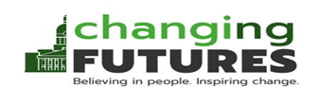
Appendix C
Nottingham City Wrap Around MDT Contact Assessment Form

The Nottingham City Wrap Around MDT is a multiagency service which supports people with a high level of unmet need to access the support, care, and treatment that they want and need.
If you, or someone you support would like to be supported by our service please complete the form below and send completed referrals to ChangingFutures.refs@frameworkha.org. If you are unsure whether to make a referral, or would like to discuss a case prior to making a referral please contact us via e-mail or by calling us on 0800 055 6191

Name of person being referred:

DOB:

Gender:

Sexuality:

Ethnicity:

Disability Status/Details of Disability:

Current Address/Housing Situation if NFA:

Contact Telephone/Point of Contact if no phone (support worker, other service, partner etc.):

Main needs:  ☐ Homelessness  ☐ Physical Health  ☐ Mental Health  ☐ Substance Misuse  ☐ Offending  ☐ Risk from Others  ☐ Risk to Self  ☐ Other (please specify) | Further information:
Aspirations - What do they want to achieve? What support would they need in order to achieve this?

Barriers – What issues are preventing access to support they need? What is stopping them from achieving what they want? Are any of the barriers systemic?

Other Service involvement:
Any other relevant information:
Referral Completed by (name of service/contact details):

CONFIDENTIALITY AND DISCLOSURE OF INFORMATION
In order for the Wrap Around MDT to give advice and support it is necessary for us to share information about you. This is to ensure that you are able to access the support, care, or treatment that you need. We may need to contact other organisations or individuals who are providing you with support, care, or treatment, or are otherwise involved with you in some relevant way.

We may also need to share personal information about you with professionals and agencies who aren’t currently involved in your support, care or treatment, but need to be in order for yours and others needs to be better met.

Information about you will not normally be shared without your knowledge or consent, however, there are certain circumstances where this may be required by law, such as if you or another person is at risk. Information will be shared in the following circumstances:

- If your GP is involved/needs to be aware of your treatment (i.e. prescribing, health risks)
- The information provided indicates a serious risk to yourself or others
- A serious threat of harm is made to a third party or it is considered that a child may be at risk. In this instance information may be provided to Social Care or the Police
- Disclosure is required by law or is necessary in the public interest

We would like to share information about you with the agencies listed below. You do not need to consent to your information being shared with all of the agencies listed, however, this may affect the advice and support we’re able to provide.

We may also want to share some information about you with services/agencies not listed below, but we will usually seek your consent before doing this. However, although the agencies listed below are in regular attendance at the multiagency meetings, there may be professionals from other services/agencies not listed below who are there to represent others being discussed.

If you would like to know what other agencies are in attendance prior to being discussed at a meeting we will happily give you this information. We will also ask for these agencies not to process information about you without your consent. If you would prefer that information about you is not shared except with organisations listed below please us let us know.

I have read and understood the confidentiality statement above and consent to be discussed at Wrap Around MDT meetings. I agree information about me can be requested from and shared with the following individuals/agencies:

Or

I confirm that I have read the confidentiality statement to the person being referred and they have understood the information provided. They have also given their verbal consent to be discussed at the Wrap Around MDT meetings and for information to be shared with and requested from the following individuals and agencies:

Signature: Date:

Please note: In normal circumstances referrals cannot be processed without consent for sharing information with Changing Futures. If you are unable to gain the consent of the person you would like to refer, but are concerned the person you would like to refer is at significant risk of harm, we may still be able to process your referral. If this is the case, please contact us ahead of making a referral so we can discuss this with you.

Agency / Individual & Contact Details | Signature | Date
Changing Futures (Framework, Al-Hurraya, POW)
Nottingham City Council (Housing / Homelessness Services, Adult Social Services, etc.)
Mental Health Services (Homeless Mental Health Team)
Primary Healthcare Services (Homeless Health Team, GP, QMC, etc.)
Drug and Alcohol Services (NRN, Clean Slate, Rough Sleeper Drug and Alcohol Treatment Team, Health Shop, etc.)
Probation
Other Framework Service (Street Outreach Team, etc.)
Juno Women’s Aid
Emmanuel House
The Friary
Other agencies which may be in attendance or you would like to attend (list as appropriate):
LEARNING AND EVALUATION
We would like to ensure that the Wrap Around MDT service works as well as possible and that services in Nottingham City are able to adequately meet the needs of people experiencing Severe and Multiple Disadvantage. We have a small team called the evaluation team which does this. The evaluation team includes staff from Changing Futures as well as independent researchers from Nottingham Trent University. The evaluation team would like to be able to study information we keep about you. This will include information from the services listed on the previous page of this form that you have agreed can share your information and may look back three months. This will help us to see how things have changed. But to do this we need your consent.
- You can withdraw this consent at any time.
- Information for the evaluation will be kept securely at all times.
- Information will be anonymised. The evaluation will never use your name and other details that might identify you such as date of birth.
- If you don’t consent to sharing information with the evaluation team, that’s fine. The Wrap Around service can still work with you.
- If you have questions just speak to someone who is working with you. They will put you in touch with the evaluation team who will be happy to answer any questions you have.
We would also like to use information about you to form case studies which can be discussed with people in senior/strategic positions within Nottingham City services. This will allow us to flag examples where things aren’t working as well as they should, and will hopefully improve how these services function.
I have understood the above information and give permission for my information to be used for learning and the evaluation of the Wrap Around MDT:
Or
I have read the above information to the person being referred and they have given verbal consent for their information to be used for learning as well as the evaluation of the Wrap Around MDT:
Signature: Date:

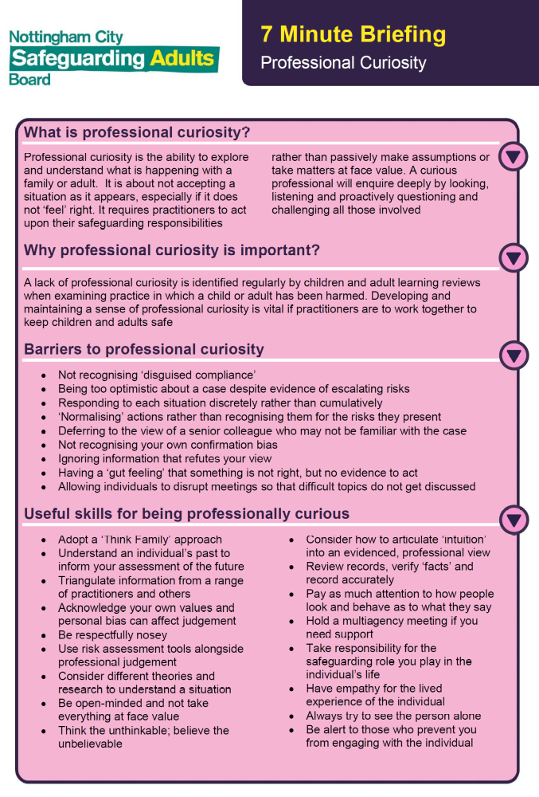
Appendix D
Professional Curiosity 7 Minute Briefing
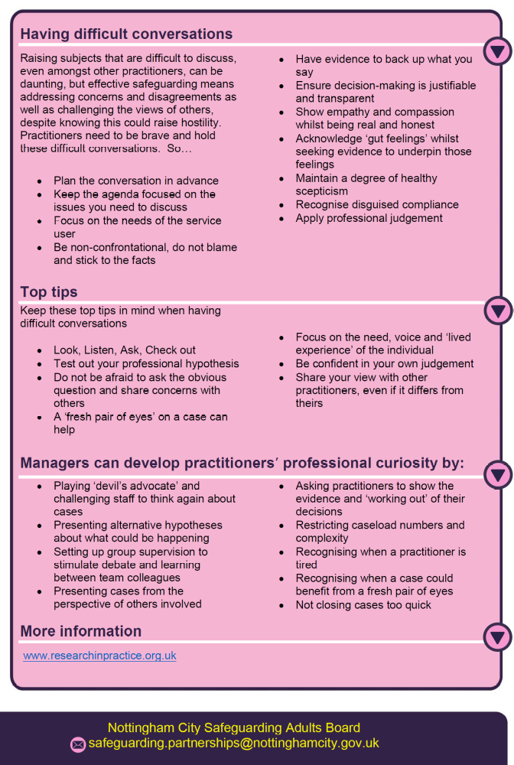

See also: the Adult Social Care Hub
Appendix E
Adult Social Care
The hub is home to information on preventive and community care options and includes options to Complete an on-line form to request support or advice.
Adult Social Care service is operational between 09:00 – 17:00, Monday to Friday – not including bank holidays.
Outside of these hours if you have a social care need that requires an immediate response please call the Emergency Duty Team on 0115 8761000

Adult Care and Support Needs (Care Act 2014 Guidance: 6.106)
The following section of the guidance (which does not constitute an exhaustive list) provides examples of an adult’s care and support needs.
a) Managing and maintaining nutrition - consider whether the adult has access to food and drink to maintain nutrition, and that the adult is able to prepare and consume the food and drink.
b) Maintaining personal hygiene - consider the adult’s ability to wash themselves and launder their clothes.
c) Managing toilet needs - consider the adult’s ability to access and use a toilet and manage their toilet needs.
d) Being appropriately clothed - consider the adult’s ability to dress themselves and to be appropriately dressed, for instance in relation to the weather to maintain their health.
e) Being able to make use of the home safely - consider the adult’s ability to move around the home safely, which could for example include getting up steps, using kitchen facilities or accessing the bathroom. This should also include the immediate environment around the home such as access to the property, for example steps leading up to the home.
f) Maintaining a habitable home environment - consider whether the condition of the adult’s home is sufficiently clean and maintained to be safe. A habitable home is safe and has essential amenities. An adult may require support to sustain their occupancy of the home and to maintain amenities, such as water, electricity and gas.
g) Developing and maintaining family or other personal relationships - consider whether the adult is lonely or isolated, either because their needs prevent them from maintaining the personal relationships they have or because their needs prevent them from developing new relationships.
h) Accessing and engaging in work, training, education or volunteering - consider whether the adult has an opportunity to apply themselves and contribute to society through work, training, education or volunteering, subject to their own wishes in this regard.
i) Making use of necessary facilities or services in the local community including public transport and recreational facilities or services - consider the adult’s ability to get around in the community safely and consider their ability to use such facilities as public transport, shops or recreational facilities when considering the impact on their wellbeing.
j) Carrying out any caring responsibilities the adult has for a child - consider any parenting or other caring responsibilities the person has. The adult may for example be a step-parent with caring responsibilities for their spouse’s children.

R2C is a Department of Communities and Local Government (DCLG) 6 month funded project.
Response to Complexity: OPCC Women’s Safety Reference Group, 28th February 2018, Dr Lyndsey Harris..
Response to Complexity: OPCC Women’s Safety Reference Group, 28th February 2018, Dr Lyndsey Harris, Assistant Professor in Criminology, Nottingham University.
Members consist of The Homeless Health Team, The Homeless Mental Health Team, Framework’s Street Outreach Team, Changing Futures SMD Embedded Practitioners, Team Leader, MDT Coordinator and MDT Navigator, Nottingham Recovery Network (The Rough Sleeper Drug & Alcohol Treatment Teams Clinical Psychologist), Juno Women’s Aid – Changing Futures specialist DVSA navigator, Emmanuel House and The Friary.

